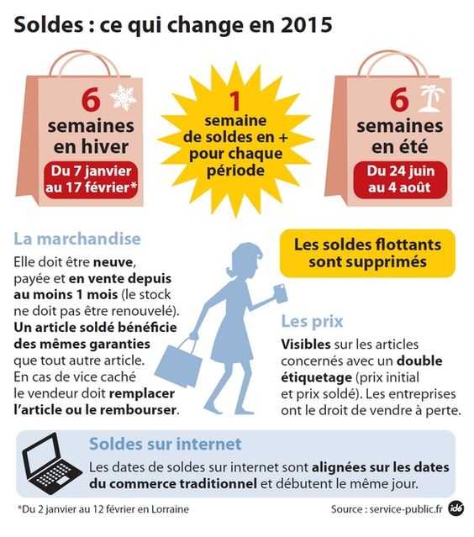

en vente= tu peux supprimé(e)=annulé(e)=éliminé(e)
acheter ce produit

caché(e)=non-visible

- Quels sont 2 protections pour les consommateurs pendant (during) les soldes ? (si=if)
_______________________________________________________________________________________________
_______________________________________________________________________________________________
_______________________________________________________________________________________________
- Regardez la 2e page, écrivez en phrases complètes 4 choses intéressantes, choquantes, différentes des USA, etc.
  - ____________________________________________________________________________________
____________________________________________________________________________________
  - ____________________________________________________________________________________
____________________________________________________________________________________
  - ____________________________________________________________________________________
____________________________________________________________________________________
  - ____________________________________________________________________________________
____________________________________________________________________________________
New Vocab you were able to make an educated guess about from both “infographies”

- __________________=_____________________
- __________________=_____________________
- __________________=_____________________
- __________________=_____________________
- __________________=_____________________
- __________________=_____________________
- __________________=_____________________
- __________________=_____________________

